**Abstract Title Capitalized and Centered**

J. Dendooven1 and M. Tallarida2

1Ghent University, Dept. of Solid State Sciences, COCOON, Krijgslaan 281/S1, 9000 Gent, Belgium

2ALBA Synchrotron, Cerdanyola del Vallès, Barcelona, Spain

*E-mail:* *corresponding.author@institute.com*

The title should be written in 14pt boldface Arial and should be capitalized and centered. After a blank line of 10pts, list the authors: use 11pt Arial, underline the presenting author and use superscript numbers for more than one affiliation. Leave a blank line of 10pts and list the address(es) of affiliation(s) using 10pt Arial. Leave again a blank line of 10pts and give the email address of the corresponding author in 10pt italic Arial and underlined. The author list, the affiliation addresses and the mailing address should be centered.

After a blank line of 10pts, the abstract should be written single-spaced, justified, using 11pt Arial. The first line of each paragraph must be indented 0.25 inches. There is no spacing between the paragraphs (both before and after). References should be quoted in square brackets [1, 2]. Use the ACS format and 10pt Arial to write the references at the end of the abstract as shown in these instructions.

It is allowed to include 1 picture. The picture should not be wrapped. Use 11pt italic Arial for the figure caption. The maximum length of the abstract, including figure and references is one page with 1 inch margins in each direction.

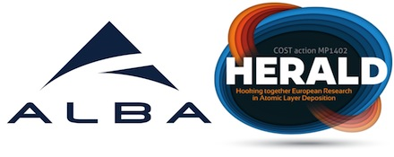

*Figure 1: Logos of the workshop organizers.*

[1] J. Dendooven et al. *J. Phys. Chem. C* 2011, 115, 6605–6610, DOI:10.1021/jp111314b

[2] M. Tallarida et al. *J. Phys. Chem. Lett.* 2014, 5, 3582−3587, DOI: 10.1021/jz501751w