REXS2025- International Conference on Resonant Elastic X-ray Scattering
Variable out-of-plane magnetic field for soft x-ray resonant magnetic reflectivity
J.-M. Tonnerre^{1,2}, J. Lacipière¹, G. Kapoujyan¹, P. Jeantet¹, E. Roy¹, F. Fettar¹, E. Contin², S. Lorcy², R. Gaudemer², H. Popescu², N. Jaouen²
¹Université Grenoble Alpes, CNRS, Grenoble INP, Institut Néel, 38042 Grenoble, France
²Synchrotron SOLEIL, Saint-Aubin, Boite Postale 48, 91192 Gif-sur-Yvette Cedex, France

It has been known that soft x-ray magnetic reflectivity is a technique for studying the magnetization profile, and therefore interfacial effects, in thin films with perpendicular magnetic anisotropy [1]. This specificity is related to the photon wavelength in the energy range, which allows measuring the reflectivity at very large angles and therefore being sensitive to the out-of-plane component of the magnetization [2]. Until now, studies were limited to magnetic layers whose magnetization was close to saturation at remanence [1,3,4].
We report on the implementation of a new magnetic device in the RESOXS chamber dedicated to x-ray resonant magnetic scattering and reflectivity in the soft x-ray range at the SEXTANTS beam line at SOLEIL. Based on five water cooled coils, it allows not only to applied the magnetic field in all the directions in the sample plane but also perpendicular to it. The amplitude of the field can be varied from -0.7 to +0.7T in the sample plane, which represents an increase by a factor 3.5 with respect to the initial device, and from -0.4 to +0.4T out-of-plane (-0.7 to 0.7 is aimed shortly) which is unique in the world to the best of our knowledge. The magnetization device allows reflectivity measurements over a large angular range, from 0 to 72° in the horizontal plane. The device capabilities (Fig. 1a) are illustrated by out-of-plane hysteresis loops exhibiting inversion sequences of 2- and 5-layer magnetic heterostructures at large and small applied field, respectively (Figs. 1a and 1b). Figure 1c displays the magnetic asymmetry variations at 3 particular field values for the latter. A reorganization of a skyrmion lattice induced by out-of-plane field was also evidenced (Fig. 1e) using CD-REXS [5].

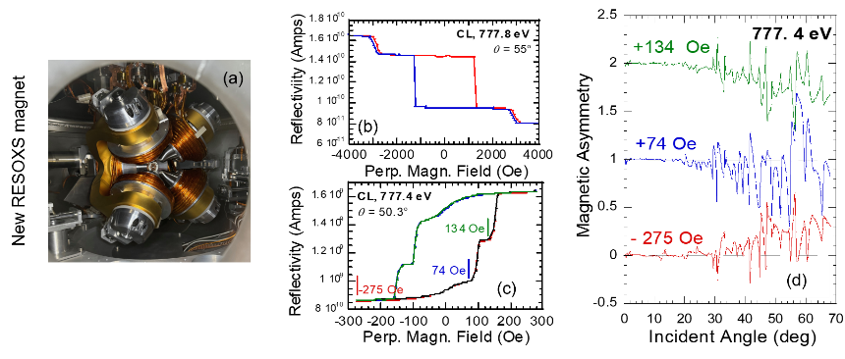 | 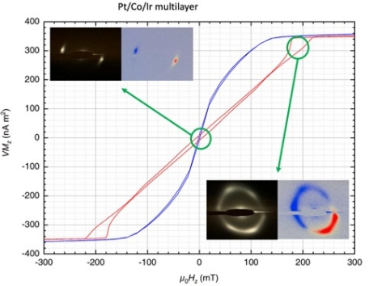  (e)

1. J.-M. Tonnerre et al., Phys. Rev. Lett. 100, 157202 (2008)
2. J.-M. Tonnerre, et al., Eur. Phys. J. Special Topics 208, 177 (2012)
3. J.-M. Tonnerre, et al., Phys. Rev. B 84, 100407(R) (2011)
4. V. Bansal et al., AIP Advances 12, 035129 (2022)
5. J.Y. Chauleau et al., Phys. Rev. Lett. 120, 037202 (2018)

